
La Academia Dolores Huerta Charter Middle School
“A Dual Language Charter Middle School”
402 W Court Ave, Las Cruces, NM 88005
Phone: 575-526-2984
Fax: 575-523-5407

The mission of La Academia Dolores Huerta is to provide a diverse bilingual educational program in the arts that fosters the development of a strong socio-cultural identity while achieving academic success.

La misión de La Academia Dolores Huerta es proporcionar un programa educativo bilingüe diverso de las artes que fomenta el desarrollo de una fuerte identidad sociocultural mientras se logra el éxito académico.

Regular Governing Council Meeting Minutes
Thursday January 15, 2026 at 5:30 PM
Meeting will be live streamed via YouTube Live Steam (refer to school website https://www.ladh.org)

- Adrian Gaytan called the meeting to order at 5:37 PM.
GC Members Present:
Elaine Palma, Secretary (responsible for meeting minutes)
Adrian Gaytan, President
Dalina Matsumoto, Treasurer
Sonia Evaro, Parent Representative

GC Members Absent:
Hilda Paz, Vice-President

Quorum was established.

Guests: Sylvy Galvan de Lucero, Head Administrator; Mirna Rodriguez, LADH Business Specialist; Francisco Rodriguez, Community Schools Coordinator

- Approval of 1.15.26 regular GC meeting agenda
Adrian Gaytan moved to approve the 1.15.26 regular GC meeting agenda; Dalina Matsumoto seconded
Roll Call Vote:
Adrian Gaytan: yes
Elaine Palma: yes
Dalina Matsumoto: yes
Sonia Evaro: yes

None opposed; motion passed

- Open forum-public input*

Public comments and observations regarding education policy and governance issues, as well as the strategic planning are heard at this time. Time limit per presenter may be imposed by Chair

Mr. Gaytan noted that at 5:37PM there was no one present and no one in the chat to provide public comment. The chat will be monitored throughout the meeting.

- Review, discussion, and possible approval of the 12.11.25 regular GC meeting minutes.
Mr. Gaytan noted that the meeting minutes had gone out for review and asked if there were any needed corrections. None were identified.

Adrian Gaytan moved to approve the 12.11.25 regular GC meeting minutes; Dalina Matsumoto seconded
Roll Call Vote:
Adrian Gaytan: yes
Elaine Palma: yes
Dalina Matsumoto: yes
Sonia Evaro: yes

None opposed; motion passed

ACTION ITEMS
- Review, discussion, and possible approval of BARs:

- 560-000-2526-0009-I: Increase to fund #27107 of $3368.00
- 560-000-2526-0010-IB: Initial budget fund #31200 of $78,470.00
- 560-000-2526-0012-I: Increase to fund#21000 of $13,934.0
- 560-000-2526-0013-I: Increase to fund #21100 of $881.00
- 560-000-2526-0014-D: Decrease in fund#25153 of $4402.00
- 560-000-2526-0015-I: Increase to fund #26204 of $5935.00
- 560-000-2526-0016-I: Increase to fund #27109 of $3.00
- 560-000-2526-0017-IB: Initial budget fund #28144 of $5.00
- 560-000-2526-0018-IB: Initial budget fund #29114 of $4.00
- 560-000-2526-0019-D: Decrease to fund #31600 of $6.00
- 560-000-2526-0020-I: increase for fund #31701 of $131.00
- 560-000-2526-0021-D: Decrease to fund#31703 of $0.31
- 560-000-2526-0022-I: Increase for fund #11000 of $85,322.68
- 560-000-2526-0023-I: Increase for fund #23000 of $1,453.00

Adrian Gaytan moved to approve BARs 560-000-2526-0009 through 0023 excluding 0011; Dalina Matsumoto seconded
Roll Call Vote:
Adrian Gaytan: yes
Elaine Palma: yes
Dalina Matsumoto: yes
Sonia Evaro: yes

None opposed; motion passed

- Review, discussion, and possible approval of Fund 26107 Permanent Cash Transfer; Presented by Mirna Rodriguez

Approval for a permanent cash transfer $6464.91 from fund #26107 to fund #11000

Adrian Gaytan moved to approve the permanent cash transfer $6464.91 from fund #26107 to fund #11000; Dalina Matsumoto seconded
Roll Call Vote:
Adrian Gaytan: yes
Elaine Palma: yes
Dalina Matsumoto: yes
Sonia Evaro: yes

None opposed; motion passed

NEW BUSINESS: DISCUSSION ITEMS ONLY – NO ACTION WILL BE TAKEN
- Finance Committee Report: presented by Sonia Evaro
  - Revenue and expense reports:
- Revenue: ending balance $805,993.24
- Expenditure report was reviewed and no concerns identified.
- Operational fund: $257,673.49
- All funds in positive except: Title I (-$7467.23); Title IV (-$2838.35); Community Schools (-$9816.63)
- Register activity report was reviewed and no concerns identified.
- Ending bank balance: $604,018.89
- Activity account balance: $10,423.95
  - Update on Parent survey regarding school budget: presented by Mirna Rodriguez
Mr. Rodriguez used Google sheets to draft budget questions which were sent to parents today (https://forms.gle/BoiYq8E2kp962imG6). Deadline for input is 1.22.25

- 2025-2026 student enrollment update: presented by Sylvy Galvan de Lucero
- 89 Students: two students were lost due to move
- Two new students are coming in tomorrow to register
- For 2026-2027: 10 students have pre-registered prior to open enrollment being announced.

- Moving update/timelines

  - Informing parents and current landlord:
- Parent response has overall been positive
  - Construction: Plan have been completed, pending one small change to increase traffic flow to two classrooms. Once change is made, the architect will submit plans to the city for approval.
- Preliminary demolition that could be completed without a permit has been completed.
- Donation letter has been generated and will be emailed to GC members.
  - Move: Continue to plan for March

- Equity Council update:
- Trainings that are strongly recommended but not required are scheduled for February in ABQ. State has not provided any funding to support travel or lodging.

- Community schools report: reported by Mr. Rodriguez
- Six recruiting performances have been scheduled so far at area elementary schools.

- Head Administrators Report to include: quarterly report addressing identification/application of grants; classroom observations; continuing education
Mrs. Galvan de Lucero sent attached report to all GC members prior to today’s meeting.
- Class Observation:
  - Informal Observations for the Spring Semester have begun throughout the past week for all core classes
- Teacher/Staff News:
  - None at this time.
- Grant Applications/Awards:
  - None at this time
- Admin Continuing Education:
  - None planned for this month

- Secretary Report: presented by Elaine Palma
- GC Recruitment: We continue to need a member with financial expertise. Mrs. Palma reported that she has been serving on the GC for almost ten years and feels it is time to make room for new members. She noted she would exit until a replacement was found and she had time to train them.
- GC Training hours: Mrs. Palma reminded the GC of the pacing guide.
  - Per pacing guide for continuing members:
July 1–September 31 | 0 hours
October 1–December 31 | 1 hour
January 1–March 31 | 3 hours
April 1–June 30 | 5 hours

- Head Administrator’s fall evaluation update: presented by Elaine Palma
Mrs. Palma reported that the HA’s fall evaluation was complete and that GC members had met with Mrs. Galvan de Lucero to review it. A final draft for review will be emailed to all GC members after today’s meeting.
- Annual calendar review:
- February:
  - Update on mission specific goals progress
  - Next GC meeting: 2.19.26

- Adrian Gaytan moved to adjourn the GC general meeting at 6:14PM; Dalina Matsumoto seconded
Roll Call Vote:
Adrian Gaytan: yes
Elaine Palma: yes
Dalina Matsumoto: yes
Sonia Evaro: yes

None opposed; motion passed

*Any individual attending a board meeting may sign in to participate in the Public Input section of the Agenda, if any. Such persons may speak on any item after the individual is recognized by the President of the Board and introduces himself/herself at the podium. The Governing Council of La Academia Dolores Huerta will not take action on any item presented under Public Input, until an opportunity to do so is afforded. La Academia Dolores Huerta will provide an interpreter for the Hearing Impaired and simultaneous Spanish translation upon request. Requests should be submitted to the chancellor’s office three days prior to the meeting.

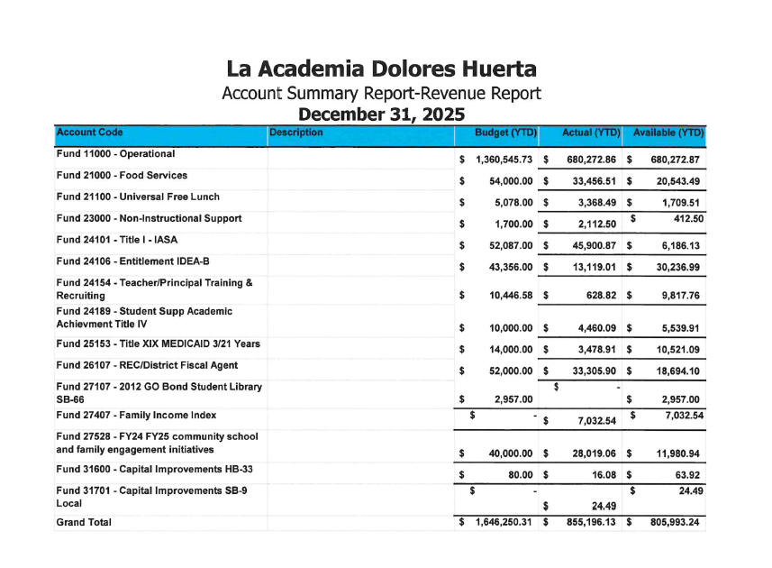

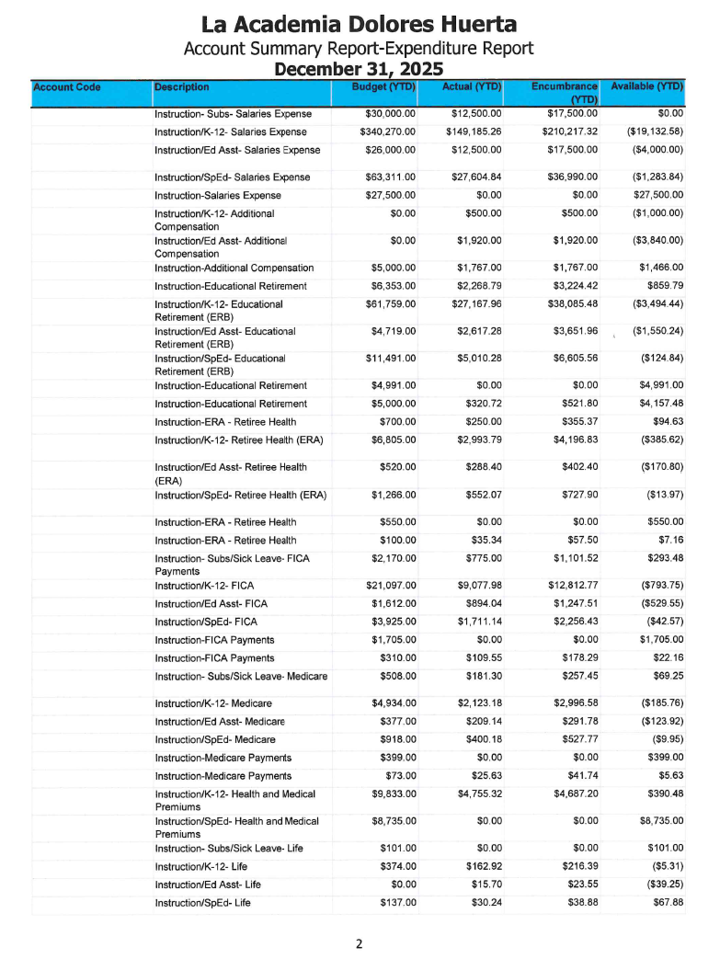
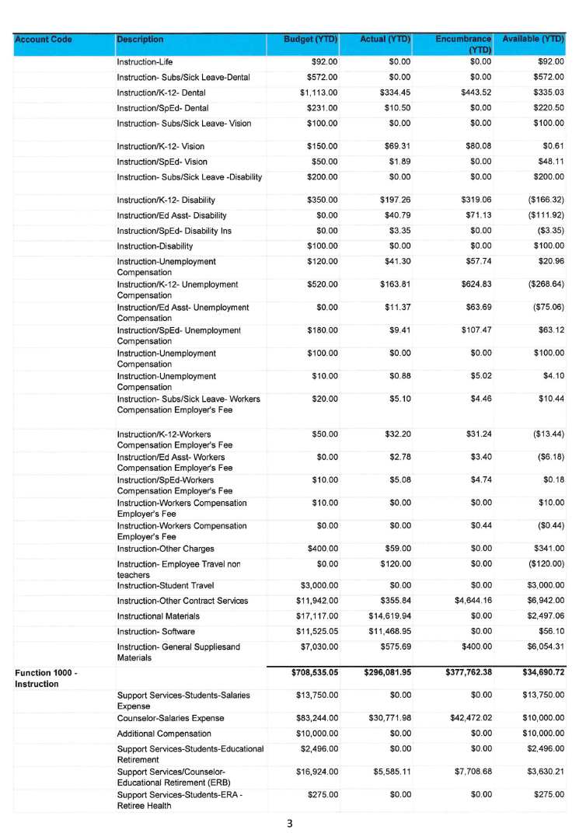
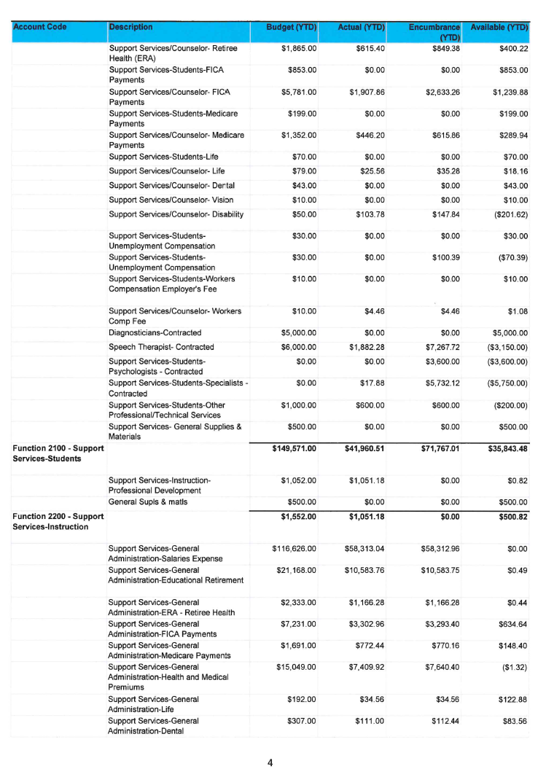
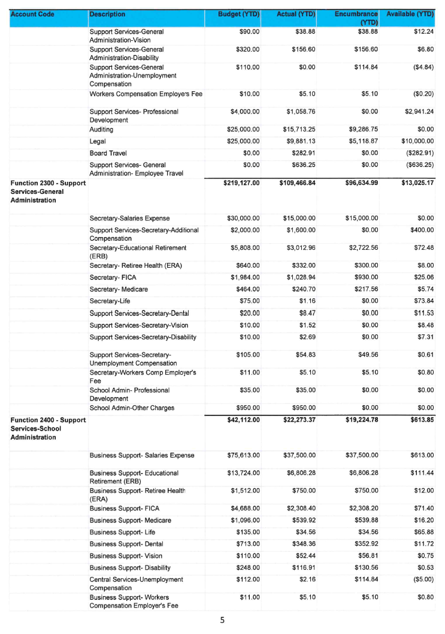
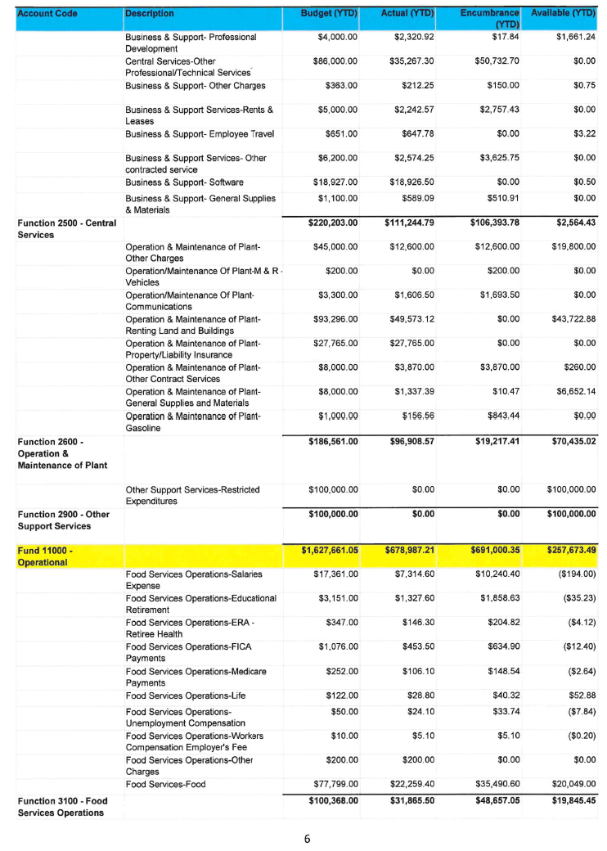
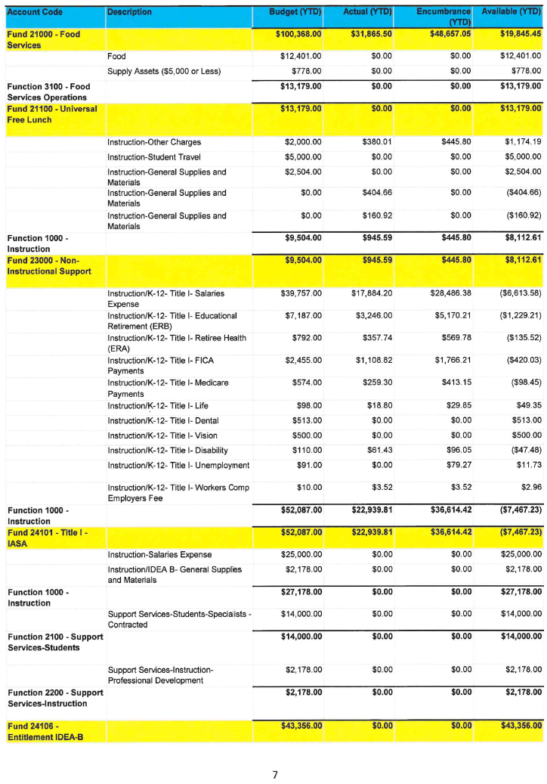
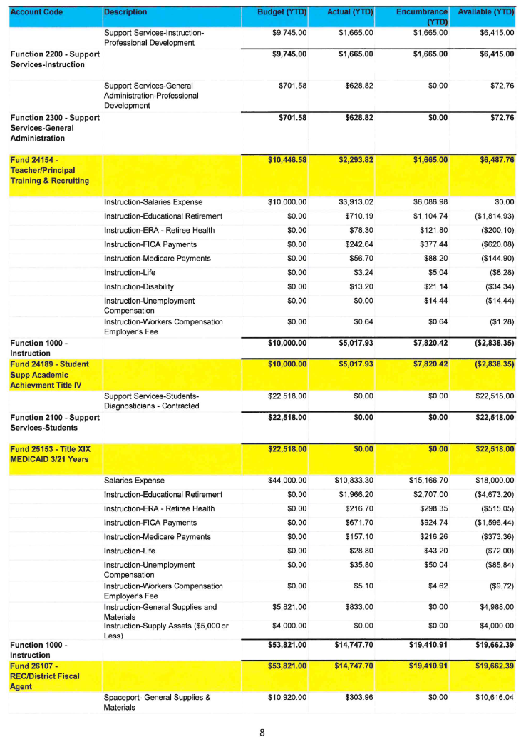
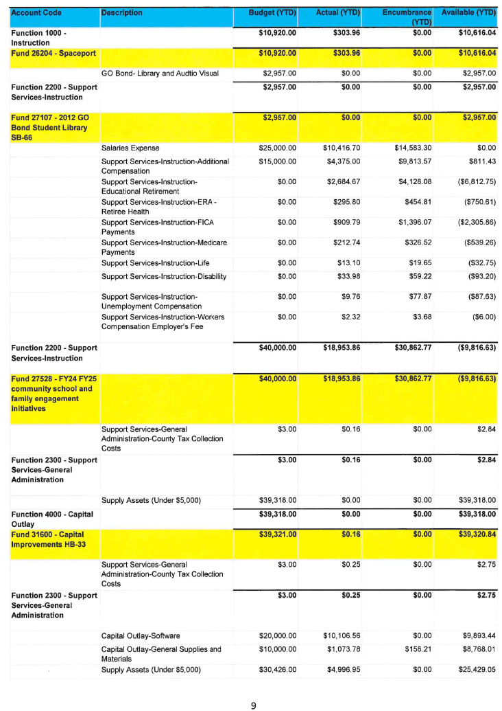
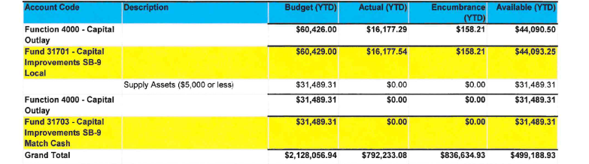
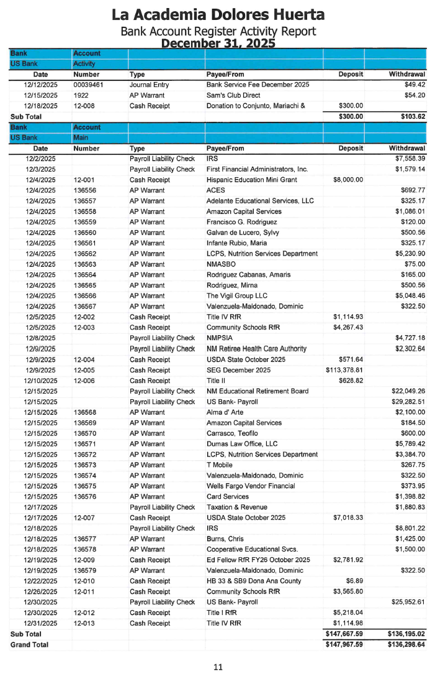
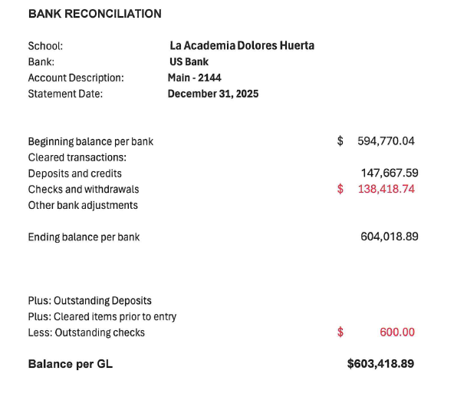
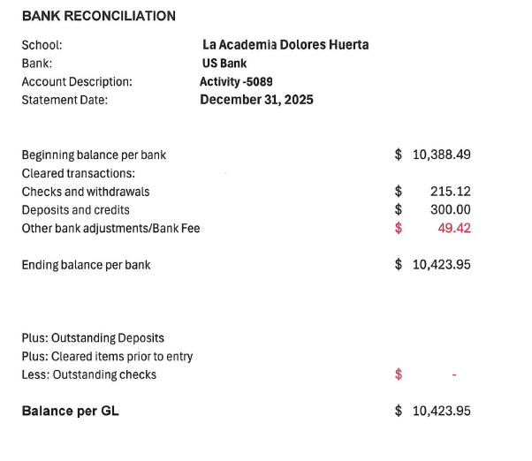
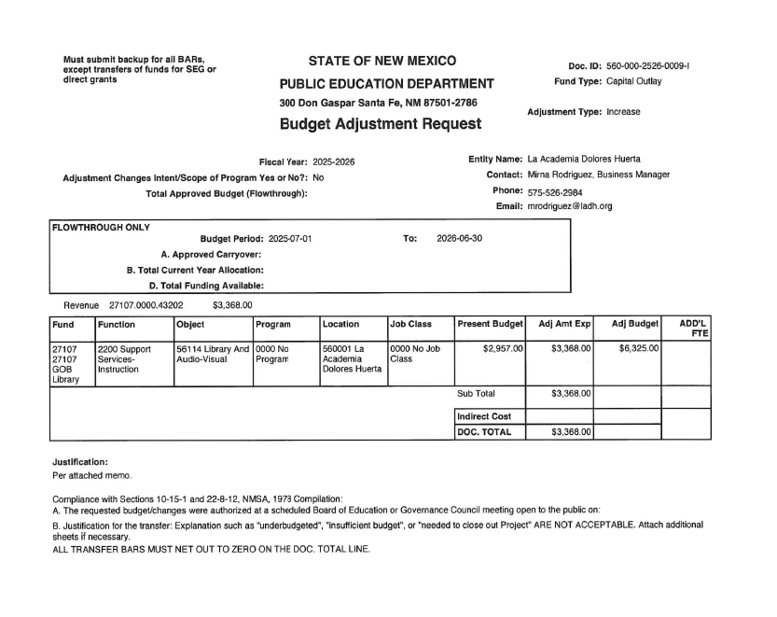
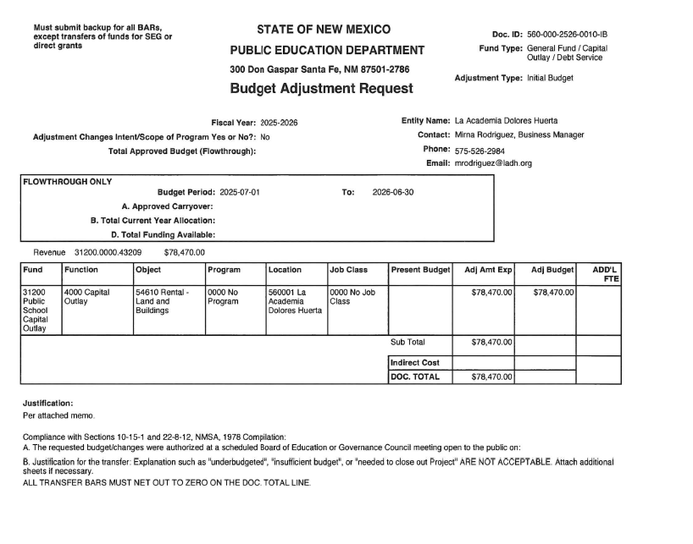
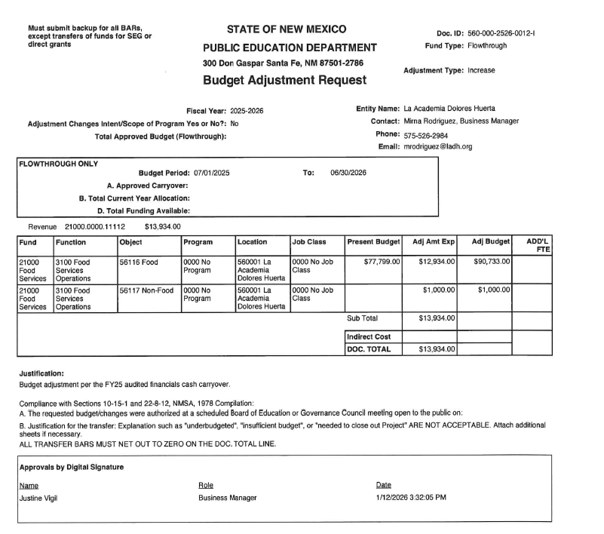
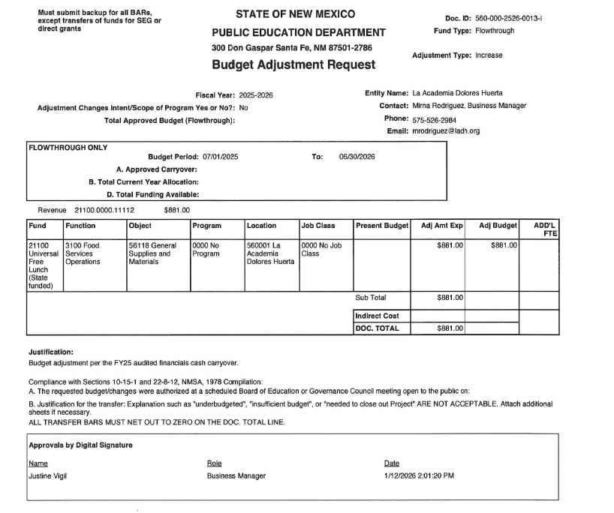
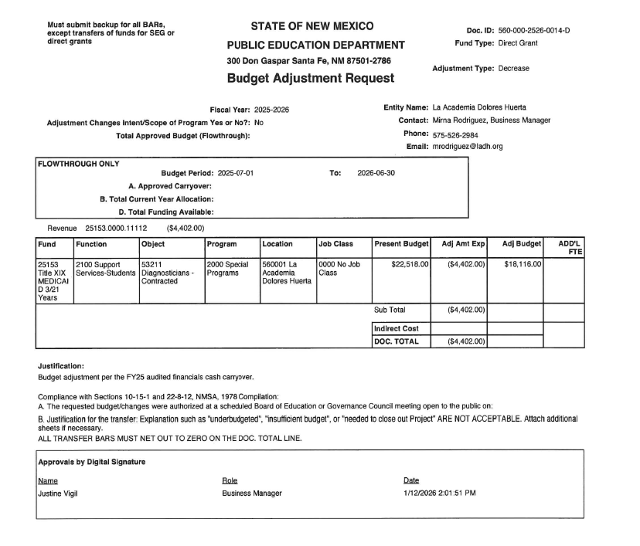
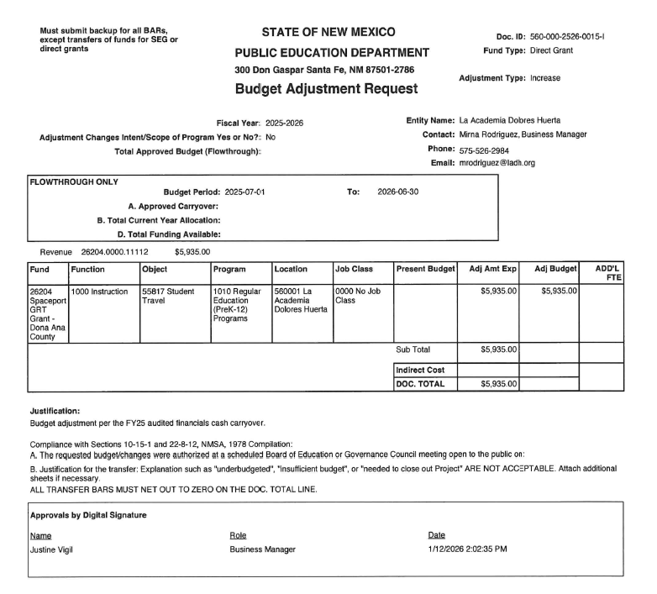
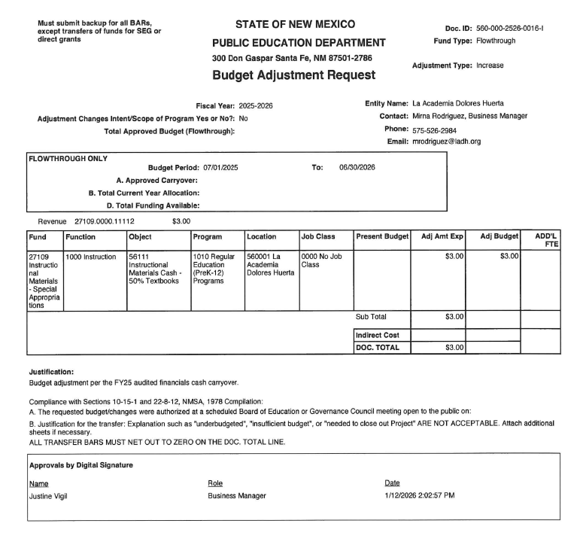
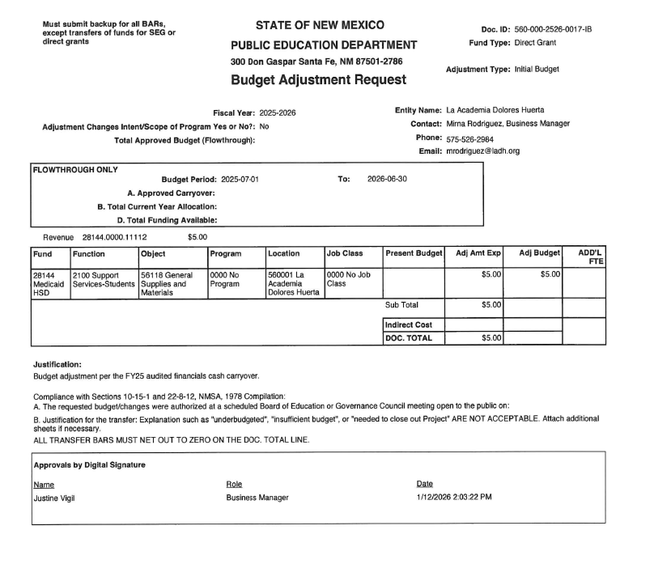
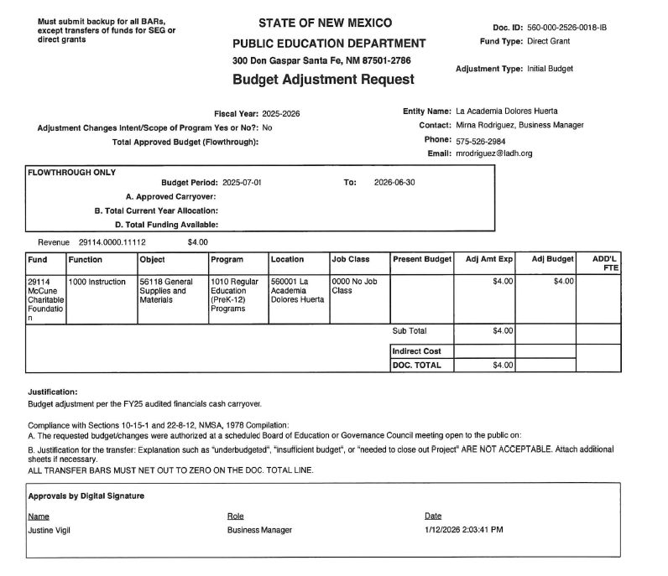
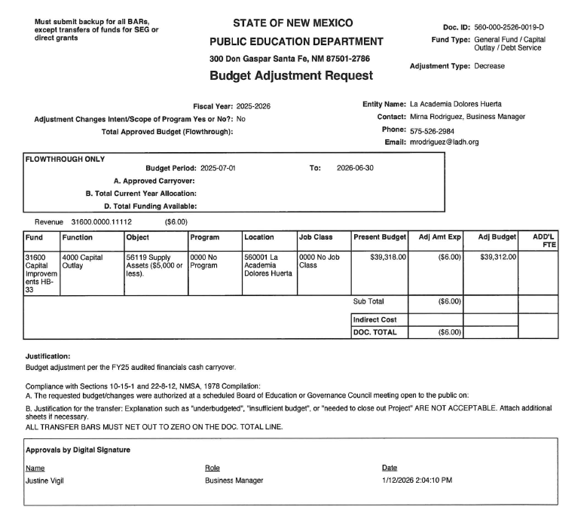
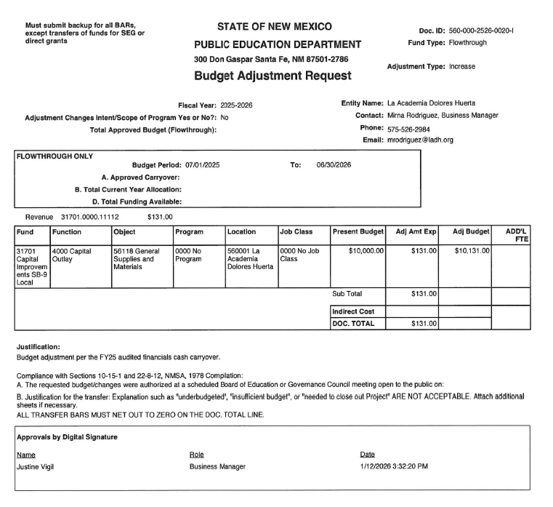
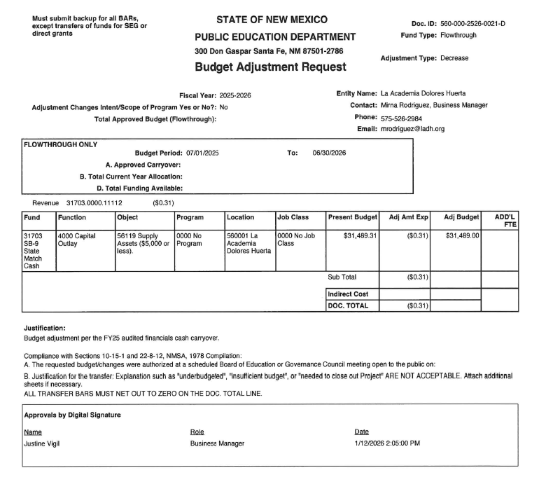
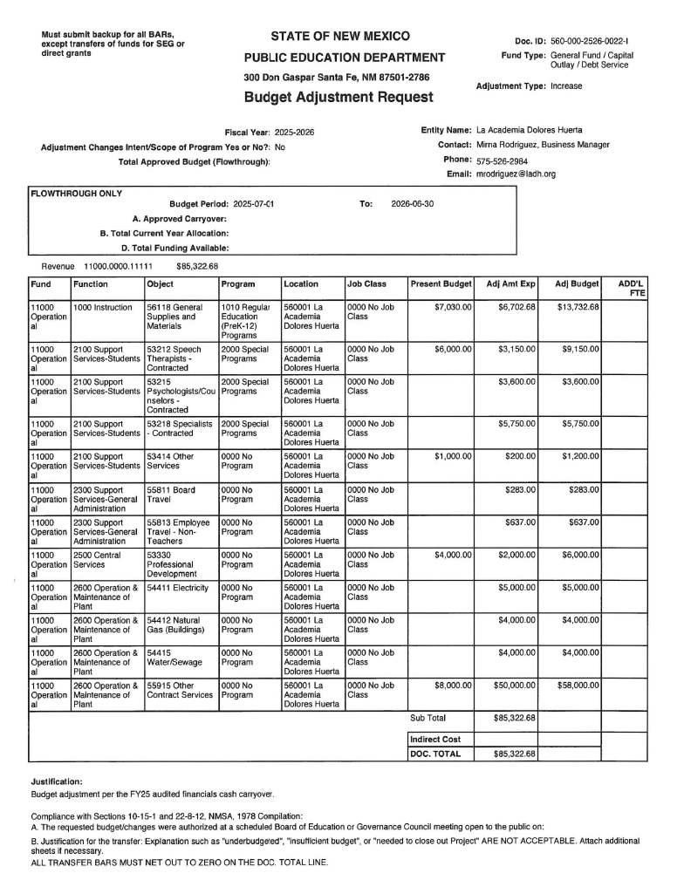
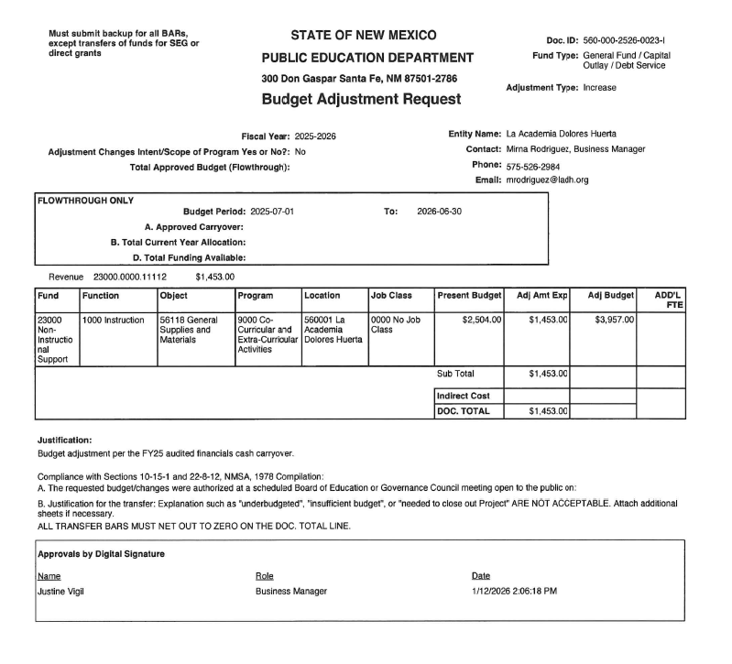

Principal’s Report
Jan 15, 2026
SY25-26 Registrations:
Grade | Enrolled | SY26/27
6th | 27 | 8
7th | 39
8th | 23
Total | 89

LADH News:
- The new semester is off to a great start, and 5 elementaries have already scheduled with us for recruiting visits.
- Open House for potential new 6th graders will be held on Jan 22, 2026
- Area high schools will be on campus on Jan 27, 2026 to pre-register students for the upcoming school year.
- LADH will be participating in the NAEP Assessment for Math & ELA on Jan. 29, 2026. This is for 8th grade only.
- The Charter School/School Choice Fair will take place on Jan. 31 at Mesilla Valley Mall from 10am-2pm
- Finance Committee met on Thursday, Jan 15, 2026 @ 5pm (See Finance Report)
Student Achievement/ Student News:
- None at this time

Professional Learning Community (PLC):
- Data Review & preparation for the Spring Semester along with Instructional Strategies for instruction & classroom management.

Class Observation:
- Informal Observations for the Spring Semester have begun throughout the past week for all core classes.

Teacher/Staff News:
- None at this time.

Grant Applications/Awards:
- None at this time

Admin Continuing Education:
- None planned for this month

Upcoming Events:
- See LADH News

Fundraisers:
- Little Ceasars Pizza Sales every Friday (beginning Jan 23, 2026)
(Always looking for Sponsors to support this fundraiser)

Community Collaboration:
- We have partnered with Brighter Bites to help families sign up for biweekly free produce boxes.
- LADH partnership with La Semilla
- Teen Connection - Frank J. Papen Ctr (After School Program), CYFD
- Casa de Mi Alma Counseling Ctr partnership to provide mental health services to students.
- A closer collaboration & partnership is being developed with Raices del Saber to build stronger feeder patterns.
- Collaboration with Southwest Family Guidance providing counseling & support to students and families.
- Poms & Associates are working with LADH to provide Parenting classes.

